IDinformation | 183
TitreFr | --
TitreEN | PM Dion Ngute leads drive to boost post-Covid economic recovery
DescriptionFr | --
DescriptionEn | Cameroon Buisness Forum, PM Dion Ngute leads drive to boost post-Covid economic recovery
Auteur | Journaux et Périodiques
TypeR | Image
Resource | 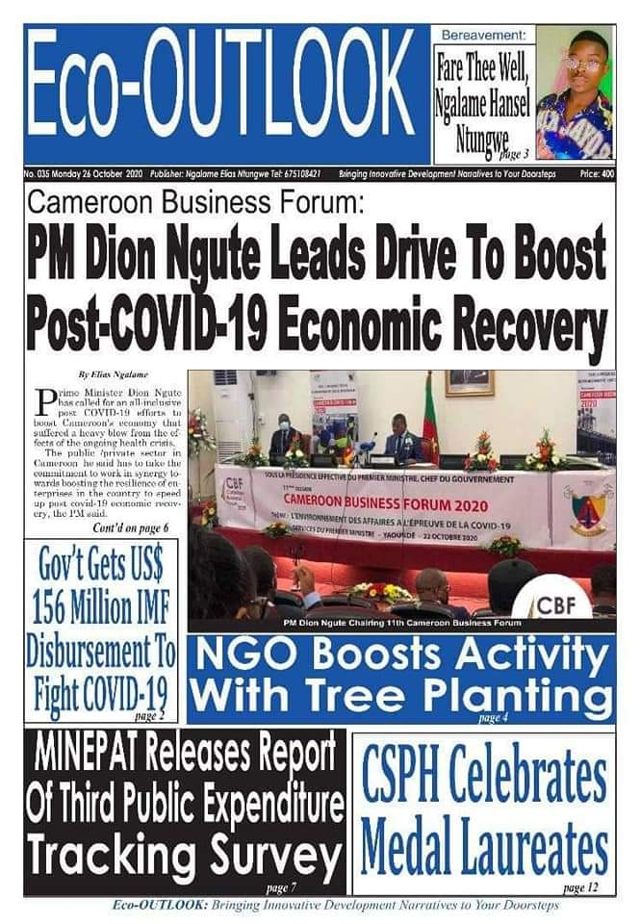
dateE | 18/11/2020
datedecreation | 26/10/2020
tag | covid-19, économie
Categorie | Economique (impact)
cat_lieu | Cameroun - Cameroon

