IDinformation | 191
TitreFr | --
TitreEN | Archibishop Kleda says he's developed covid-19 cure
DescriptionFr | --
DescriptionEn | Archibishop Kleda says he's developed covid-19 cure
Auteur | Journaux et Périodiques
TypeR | Image
Resource | 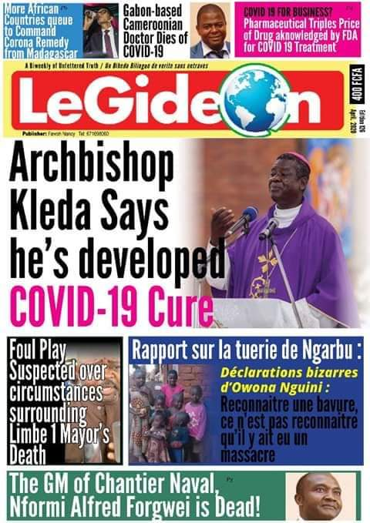
dateE | 20/11/2020
datedecreation | 28/04/2020
tag | covid-19, traitement
Categorie | Traitement
cat_lieu | Cameroun - Cameroon

