IDinformation | 212
TitreFr | --
TitreEN | Uniformed men, state agents accused of sabotaging fight against Covid-19
DescriptionFr | --
DescriptionEn | Uniformed men, state agents accused of sabotaging fight against Covid-19. Laquintinie accused for asking patients for payement!
Auteur | Journaux et Périodiques
TypeR | Image
Resource | 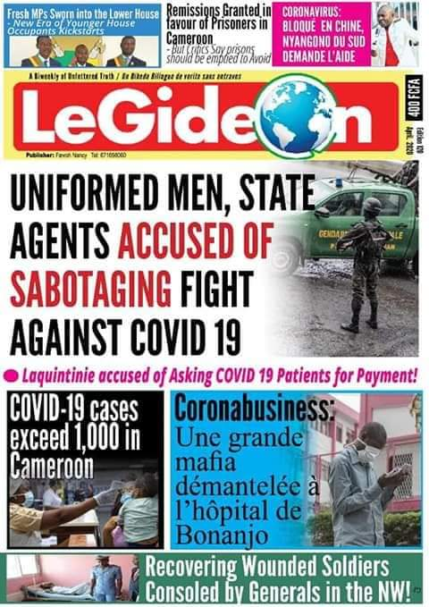
dateE | 24/11/2020
datedecreation | 20/04/2020
tag | covid-19, precaution, prévention
Categorie | Prévention
cat_lieu | Cameroun - Cameroon

