IDinformation | 308
TitreFr | --
TitreEN | Cameroon hit by second wave of covid-19
DescriptionFr | --
DescriptionEn | Cameroon hit by second wave of covid-19: 318 new cases, 4 deaths reported with 25 infections in Douala schools within a week.
Auteur | Journaux et Périodiques
TypeR | Image
Resource | 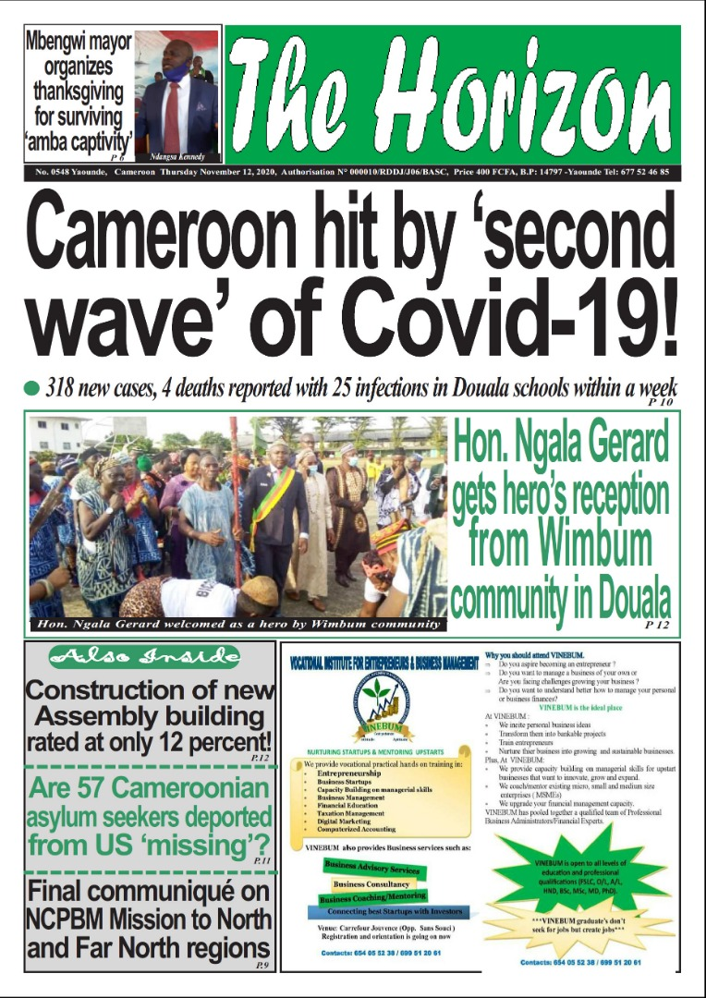
dateE | 02/06/2022
datedecreation | 12/11/2020
tag | covid-19, évolution de la pandémie
Categorie | Evolution de la pandémie
cat_lieu | Douala

