IDinformation | 198
TitreFr | --
TitreEN | Annulation of the public celebrations of the 2020 editions of the labour day and national day
DescriptionFr | --
DescriptionEn | Annulation of the public celebrations of the 2020 editions of the labour day and national day because of the coronavirus pandemic
Auteur | Présidence de la République
TypeR | Image
Resource | 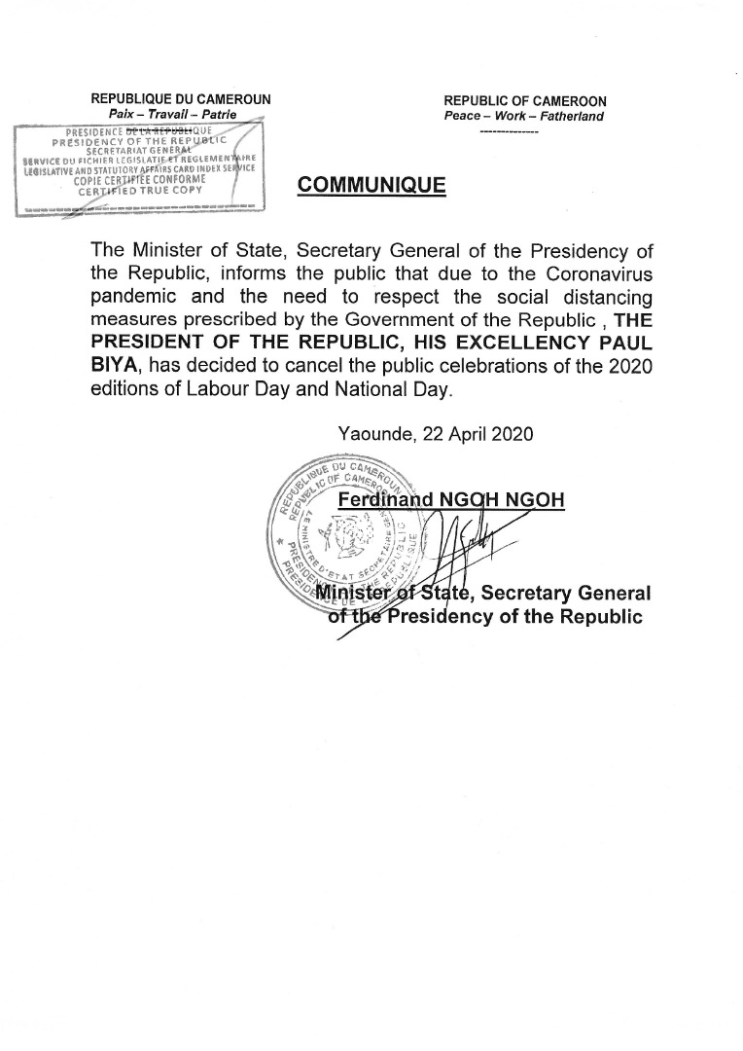
dateE | 23/11/2020
datedecreation | 22/04/2020
tag | covid-19, precaution, prévention
Categorie | Environnement (impact)
cat_lieu | Cameroun - Cameroon

