IDinformation | 299
TitreFr | --
TitreEN | Treatment protocol for less severe cases of covid-19 at the Regional Hospital Limbe
DescriptionFr | --
DescriptionEn | Treatment protocol for less severe (without signs of respiratory failure) cases of covid-19 at the Regional Hospital Limbe
Auteur | Ministère de la santé publique (Minsanté)
TypeR | Image
Resource | 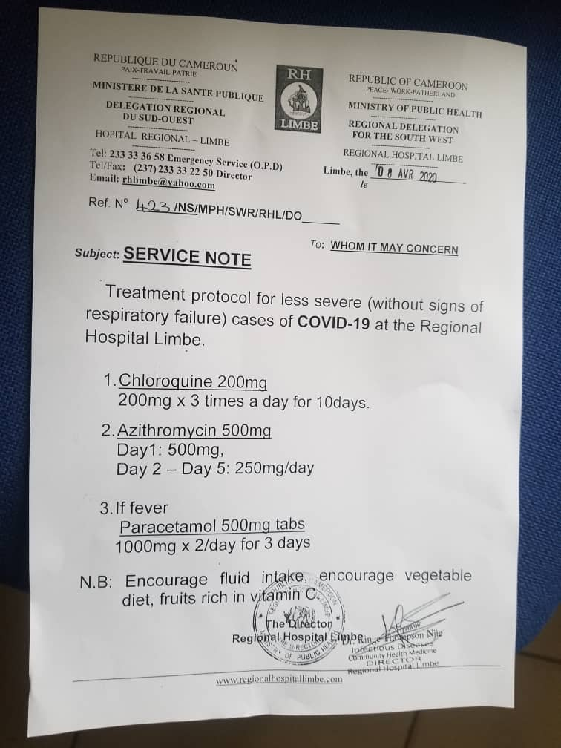
dateE | 24/05/2022
datedecreation | 08/04/2020
tag | covid-19, traitement
Categorie | Traitement
cat_lieu | Région du Sud-ouest

